**Department of Electrical Engineering**

**Faculty Member:** Arshad Nazir **Dated:** 11/12/2021

**Semester:** 3rd **Section:** BEE 12C

**Group No.: 7**

**EE-221: Digital Logic Design**

Lab 10: Magnitude Comparator

|  |  |  |  |  |  |  |  |
| --- | --- | --- | --- | --- | --- | --- | --- |
|  |  | **PLO4/CLO4** | **PLO4/CLO4** | **PLO5/CLO5** | **PLO8/CLO6** | **PLO9/CLO7** |  |
| **Name** | **Reg. No** | **Viva / Lab Performance** | **Analysis of data in Lab Report** | **Modern Tool Usage** | **Ethics and Safety** | **Individual and Teamwork** | **Total marks Obtained** |
|  |  | **5 Marks** | **5 Marks** | **5 Marks** | **5 Marks** | **5 Marks** | **25 Marks** |
| **Muhammad Adil Azeem** | **342459** |  |  |  |  |  |  |
| **Muhammad Umer** | **345834** |  |  |  |  |  |  |
| **Raahim Ahmad Waqar** | **342287** |  |  |  |  |  |  |
| **Saad Bakhtiar** | **341150** |  |  |  |  |  |  |
| **Syed Aun Ali Kazmi** | **342384** |  |  |  |  |  |  |

## Lab 10: Magnitude Comparator

This Lab Activity has been designed to familiarize students with design and working of combinational circuits using basic logic gates.

**Objectives:**

* Design and Implementation of 2-bit magnitude comparator using classical design method learned in the class.
* Design of a 4-bit magnitude comparator using a 4-bit adder IC and logic gates
* Verification of 4 bit comparator IC
* Dataflow modeling in Verilog HDL

**Lab Instructions**

* This lab activity comprises three parts, namely Pre-lab, Lab tasks, and Post-Lab Viva session.
* The lab report will be uploaded on LMS three days before scheduled lab date. The students will get hard copy of lab report, complete the Pre-lab task before coming to the lab and deposit it with teacher/lab engineer for necessary evaluation. Alternately each group to upload completed lab report on LMS for grading.
* The students will start lab task and demonstrate design steps separately for stepwise evaluation (course instructor/lab engineer will sign each step after ascertaining functional verification)
* Remember that a neat logic diagram with pins numbered coupled with nicely patched circuit will simplify trouble-shooting process.
* After the lab, students are expected to unwire the circuit and deposit back components before leaving.
* The students will complete lab task and submit complete report to Lab Engineer before leaving lab.
* **The Total duration for the lab is 3 hrs. After lab duration, a deduction of 5 marks per day will be done for late submission.**
* **A lab with in-complete lab tasks will not be accepted.**
* There are related questions at the end of this activity. Give complete answers.

**Pre – Lab Tasks**

**Pre – Lab Task 1**

**What do you mean by a comparator circuit? Draw the truth table for a 1-bit magnitude comparator. The comparator has 2 inputs (A and B) and 3 outputs E, L and G for (A=B), (A<B) and (A>B) respectively. For example, one combination is filled in below example, for your guidance.**

A digital comparator or magnitude comparator is a hardware electronic device that takes two numbers as input in binary form and determines whether one number is greater than, less than or equal to the other number.

|  |  |  |  |  |
| --- | --- | --- | --- | --- |
| **A** | **B** | **E (A=B)** | **G (A>B)** | **L (A<B)** |
| 0 | 0 | **1** | **0** | **0** |
| 0 | 1 | **0** | **1** | **0** |
| 1 | 0 | **0** | **0** | **1** |
| 1 | 1 | **1** | **0** | **0** |

**Simplify the functions E, G and L and give their Logic diagrams.**

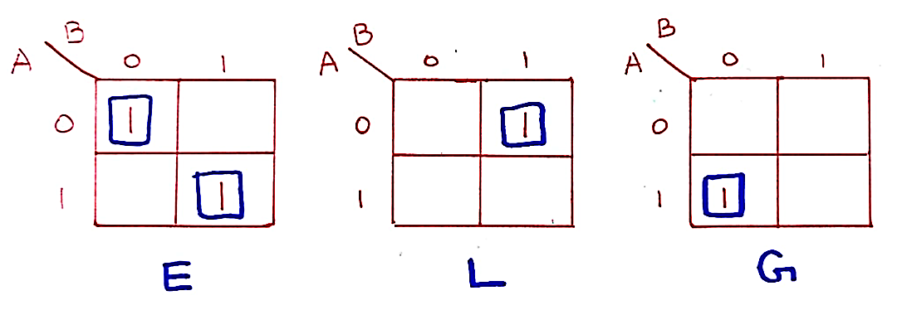

|  |  |
| --- | --- |
| **Function** | **Expression** |
| E | A’B’ + AB |
| L | A’B |
| G | AB’ |

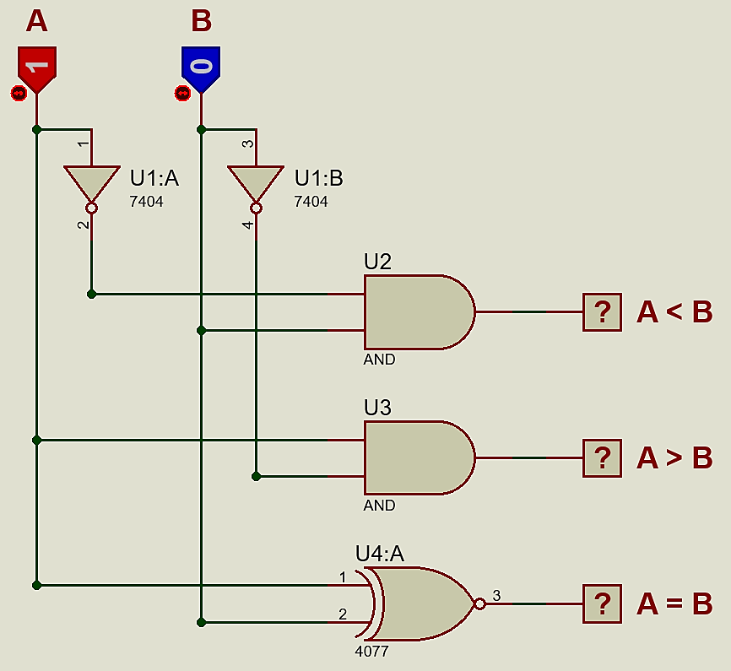

**Pre – Lab Task 2**

**Design a 2-bit magnitude comparator.**

**List the truth table.**

|  |  |  |  |  |  |  |
| --- | --- | --- | --- | --- | --- | --- |
| **Inputs** | | | | **Outputs** | | |
| **A1** | **A0** | **B1** | **B0** | **L (A<B)** | **E (A=B)** | **G (A>B)** |
| 0 | 0 | 0 | 0 | **0** | **1** | **0** |
| 0 | 0 | 0 | 1 | **1** | **0** | **0** |
| 0 | 0 | 1 | 0 | **1** | **0** | **0** |
| 0 | 0 | 1 | 1 | **1** | **0** | **0** |
| 0 | 1 | 0 | 0 | **0** | **0** | **1** |
| 0 | 1 | 0 | 1 | **0** | **1** | **0** |
| 0 | 1 | 1 | 0 | **1** | **0** | **0** |
| 0 | 1 | 1 | 1 | **1** | **0** | **0** |
| 1 | 0 | 0 | 0 | **0** | **0** | **1** |
| 1 | 0 | 0 | 1 | **0** | **0** | **1** |
| 1 | 0 | 1 | 0 | **0** | **1** | **0** |
| 1 | 0 | 1 | 1 | **1** | **0** | **0** |
| 1 | 1 | 0 | 0 | **0** | **0** | **1** |
| 1 | 1 | 0 | 1 | **0** | **0** | **1** |
| 1 | 1 | 1 | 0 | **0** | **0** | **1** |
| 1 | 1 | 1 | 1 | **0** | **1** | **0** |

**Simplify each of the functions E, G and L and give the logic diagram**

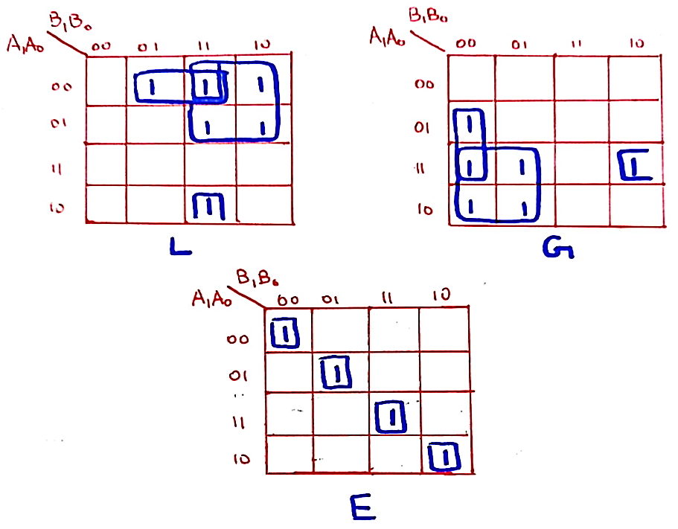

|  |  |  |
| --- | --- | --- |
| **Function** | **Expression** | **Simplified** |
| E | A1’A0’B1’B0’ + A1’A0B1’B0 + A1A0B1B0 + A1A0’B1B0’ | (A1⊙B1)(A0⊙B0) |
| L | A1’B1 + A0’B1B0 + A1’A0’B0 | N/A |
| G | A1B1’ + A0B1’B0’ + A1A0B0’ | N/A |

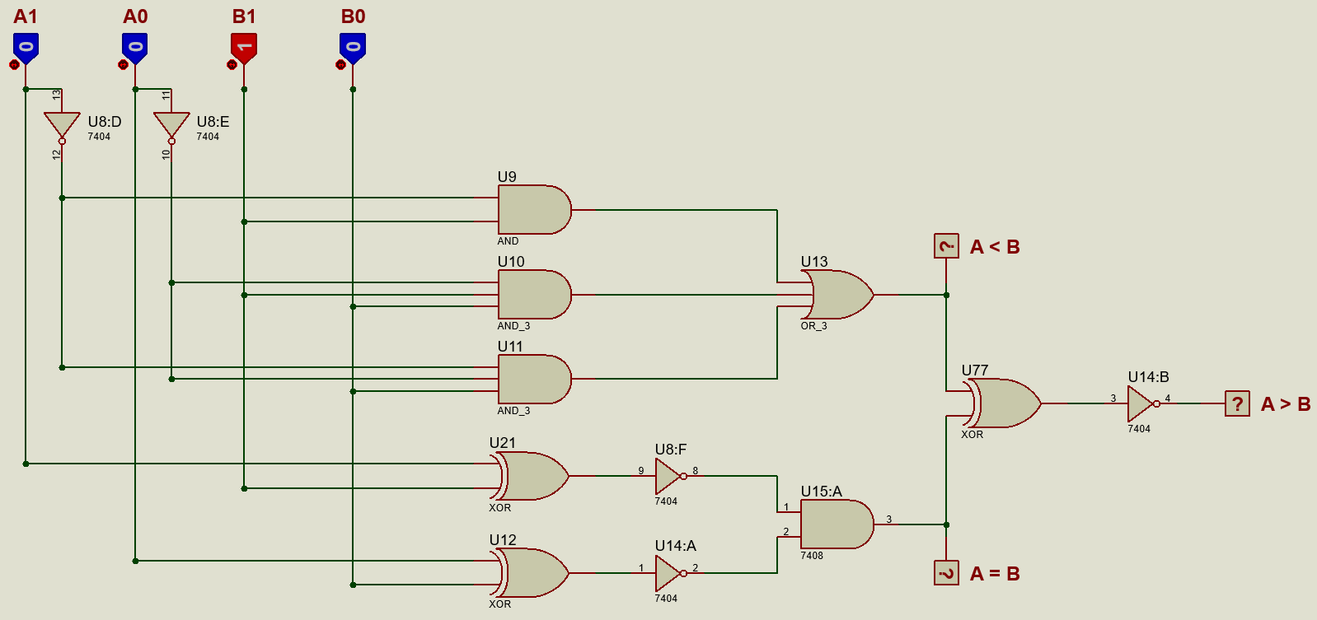

**Lab Tasks**

**Lab Task 1**

**Implement the 2 – bit Comparator circuit you arrived in your Pre – lab Task. Give the Complete circuit schematic diagram here again.**

**Proteus Simulation**



**Hardware Implementation**

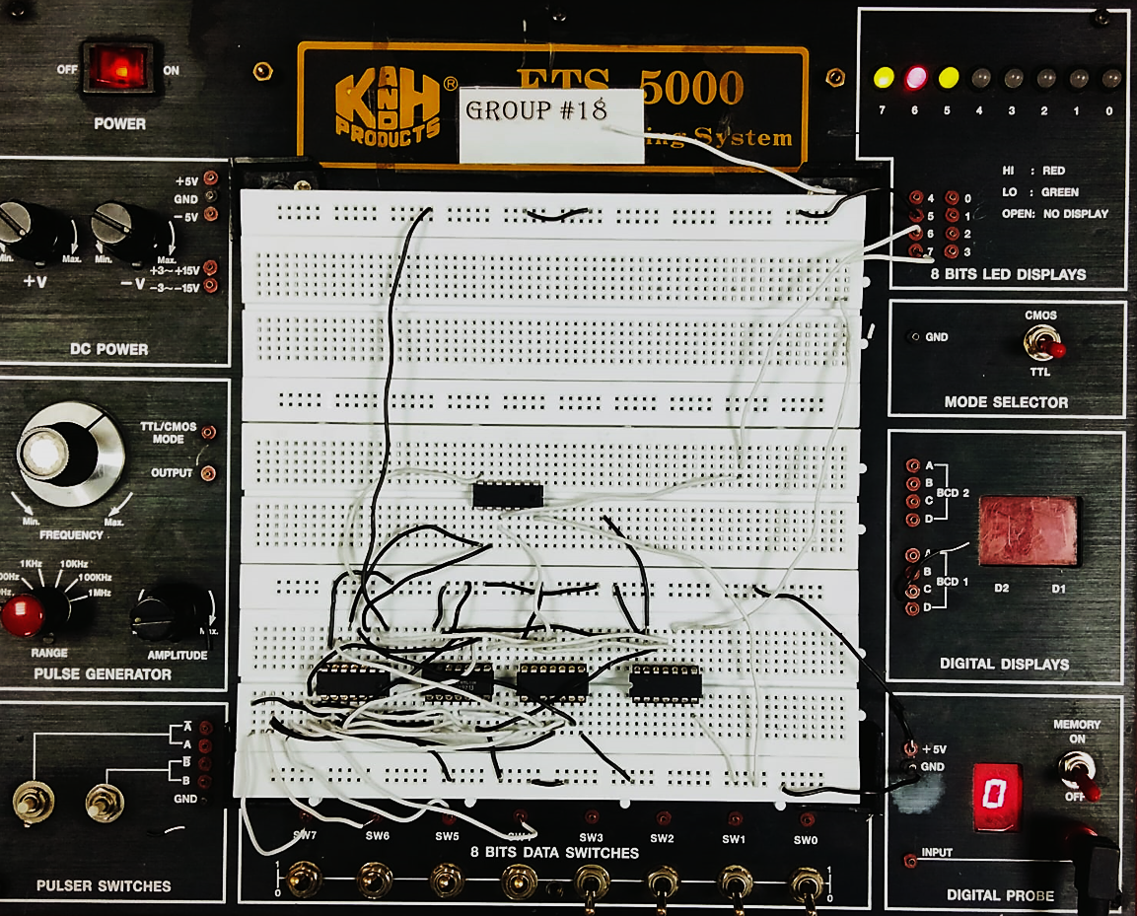

**Lab Task 2**

**Get the 4-bit magnitude comparator IC (7485) from the lab. Give its function table, Pin Layout and show its implemented hardware. Does your results match with task4 results? If not state its reason.**

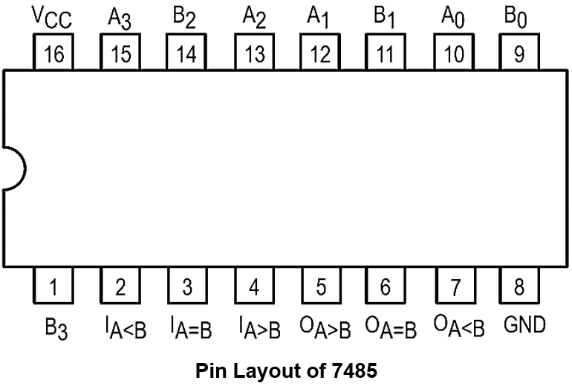

**Function Table**

|  |  |  |  |  |  |  |  |  |  |  |
| --- | --- | --- | --- | --- | --- | --- | --- | --- | --- | --- |
| **Inputs** | | | | | | | | **Outputs** | | |
| **A3** | **A2** | **A1** | **A0** | **B3** | **B2** | **B1** | **B0** | **E (A=B)** | **G (A>B)** | **L (A<B)** |
| 0 | 0 | 0 | 0 | 0 | 0 | 0 | 0 | **1** | **0** | **0** |
| 0 | 0 | 0 | 1 | 0 | 0 | 1 | 1 | **0** | **1** | **0** |
| 0 | 0 | 1 | 0 | 0 | 0 | 0 | 0 | **0** | **0** | **1** |
| 0 | 0 | 1 | 1 | 0 | 0 | 0 | 1 | **0** | **0** | **1** |
| 0 | 1 | 0 | 0 | 0 | 1 | 0 | 0 | **1** | **0** | **0** |
| 0 | 1 | 0 | 1 | 0 | 0 | 1 | 1 | **0** | **0** | **1** |
| 0 | 1 | 1 | 0 | 0 | 1 | 0 | 1 | **0** | **0** | **1** |
| 0 | 1 | 1 | 1 | 1 | 0 | 0 | 1 | **0** | **1** | **0** |
| 1 | 0 | 0 | 0 | 1 | 0 | 0 | 0 | **1** | **0** | **0** |
| 1 | 0 | 0 | 1 | 0 | 1 | 1 | 1 | **0** | **0** | **1** |
| 1 | 0 | 1 | 0 | 1 | 0 | 1 | 1 | **0** | **1** | **0** |
| 1 | 0 | 1 | 1 | 1 | 0 | 1 | 0 | **0** | **0** | **1** |
| 1 | 1 | 0 | 0 | 1 | 1 | 0 | 0 | **1** | **0** | **0** |
| 1 | 1 | 0 | 1 | 1 | 1 | 1 | 0 | **0** | **1** | **0** |
| 1 | 1 | 1 | 0 | 1 | 1 | 1 | 1 | **0** | **1** | **0** |
| 1 | 1 | 1 | 1 | 1 | 1 | 1 | 1 | **1** | **0** | **0** |

**Hardware Implementation**

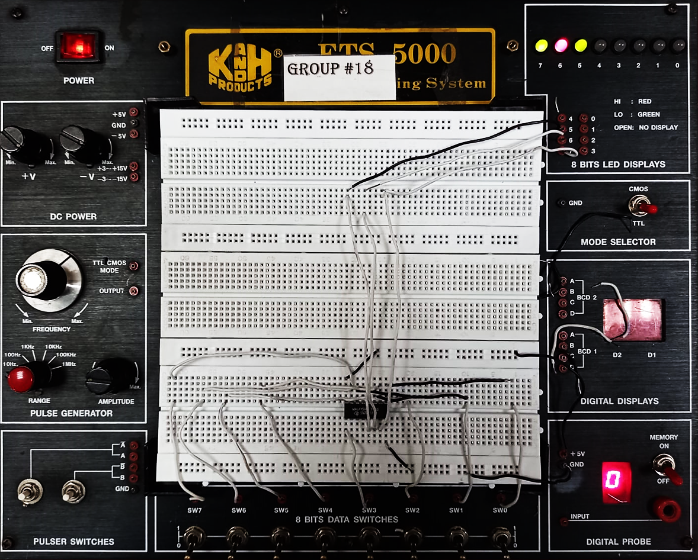

**Write verilog code of 2 bit comparator using dataflow modeling.**

module comparator(e, g , l, a1, a0, b1, b0);

    input a1, a0, b1, b0;

    output e, g , l;

    assign e = (a0 ^~ b0) & (a1 ^~ b1);

    assign g = (a1 & ~b1) | (a0 & ~b1 & ~b0) | (a1 & a0 & ~b0);

    assign l = (~a1 & b1) | (~a0 & b1 & b0) | (~a1 & ~a0 & b0);

endmodule

module testbench();

    reg A1, A0, B1, B0;

    wire E, G, L;

    comparator t1(E, G, L, A1, A0, B1, B0);

    initial begin

        #100 A1 = 0; A0 = 0; B1 = 0; B0 = 0;

        #100 A1 = 0; A0 = 0; B1 = 0; B0 = 1;

        #100 A1 = 0; A0 = 0; B1 = 1; B0 = 0;

        #100 A1 = 0; A0 = 0; B1 = 1; B0 = 1;

        #100 A1 = 0; A0 = 1; B1 = 0; B0 = 0;

        #100 A1 = 0; A0 = 1; B1 = 0; B0 = 1;

        #100 A1 = 0; A0 = 1; B1 = 1; B0 = 0;

        #100 A1 = 0; A0 = 1; B1 = 1; B0 = 1;

        #100 A1 = 1; A0 = 0; B1 = 0; B0 = 0;

        #100 A1 = 1; A0 = 0; B1 = 0; B0 = 1;

        #100 A1 = 1; A0 = 0; B1 = 1; B0 = 0;

        #100 A1 = 1; A0 = 0; B1 = 1; B0 = 1;

        #100 A1 = 1; A0 = 1; B1 = 0; B0 = 0;

        #100 A1 = 1; A0 = 1; B1 = 0; B0 = 1;

        #100 A1 = 1; A0 = 1; B1 = 1; B0 = 0;

        #100 A1 = 1; A0 = 1; B1 = 1; B0 = 1;

    end

endmodule

